St John the Baptist Catholic School Soccer Information
St John the Baptist Catholic School - Oval locations & Game Times
Cabra Dominican College – U7, U8, U9 & Seniors
- Park in Woolworths Cumberland Pk and enter via Little St. No Parking available in Cabra College grounds.
- U7, U8 & U9 pitch is located on the right-hand side as you walk in.
- Senior pitches to the left (middle and Western end Pitches) - big oval.
Grade | Team Name | Division | TIME | OVAL
Under 7  Phoenix | St John the  Baptist | Red Division | 8:30 am | Cabra College - Small pitch
Under 8  Jets | St John the  Baptist | Blue Division | 9:15am | Cabra College - Small pitch
Under 9  United | St John the  Baptist 1 | Red Division | 10:00 am | Cabra College - Small pitch
Under 9  Glory | St John the  Baptist 2 | Green Division | 10:45am | Cabra College - Small pitch
Senior  Wanderers | St John the  Baptist 1 | Red Division | 10:45am | Cabra College -  Big oval
Senior  Victory | St John the  Baptist 2 | Blue Division | 11:40am | Cabra College -  Big oval

School Sport Coordinator:
Term 2: Mary Murray 0412 836 953
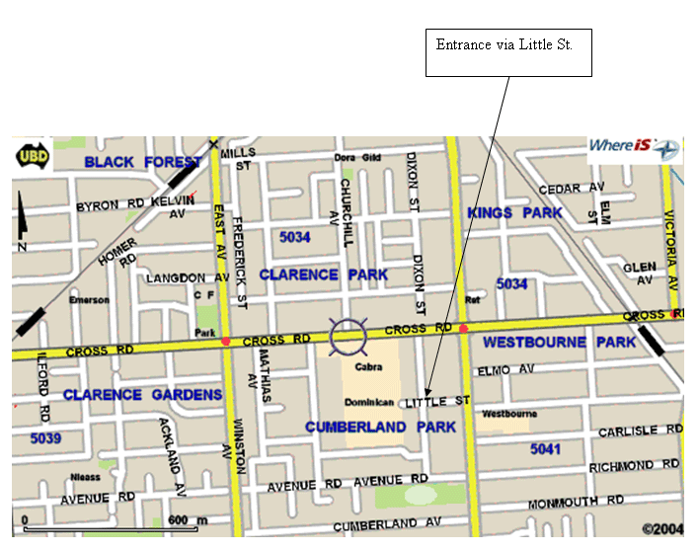
St John the Baptist Catholic School ph 8218 3300

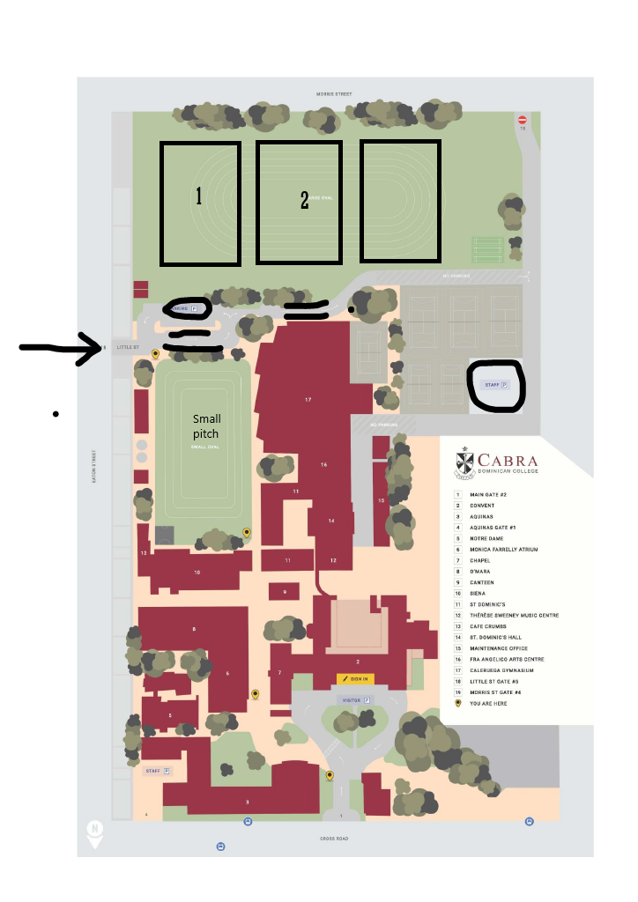
Large Pitch
Main Oval
Seniors
Small Pitch
U7, U8, U9

