BLACKWOOD PRIMARY SCHOOL – PLAYING TIMES

LOCATION: 4 SEYMOUR STREET EDEN HILLS
CONTACT: Serena Dickon, 0419 819 708, serena.yeates@bigpond.com

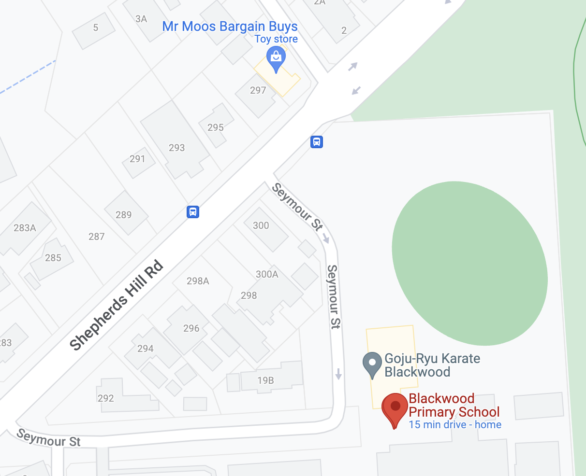
SOCCER GAMES PLAYED ON FRONT OVAL

PLAYING TIMES:

TEAM | TIME
Under 9 | 10:00am
Under 10 | 11:00am
Seniors | 9:00am

