Eden Hills Primary School

Game Location
Frank Smith Park, Magarey Road, Coromandel Valley
(Note: Not at our school!)

Parking around the oval and off to the side of the track
The entry gate to Frank Smith Park gets locked at the completion of the matches so remember to move out promptly

Killer fundraising BBQ with cash and card!

Coordinator – Nick O’Connor
EMAIL – nickoconnor@y7mail.com | PHONE 0466 513 190

Game Times
GRADE | TIME | PITCH
Under 9 | 9:00 | 2a
Senior | 10:00 | 2
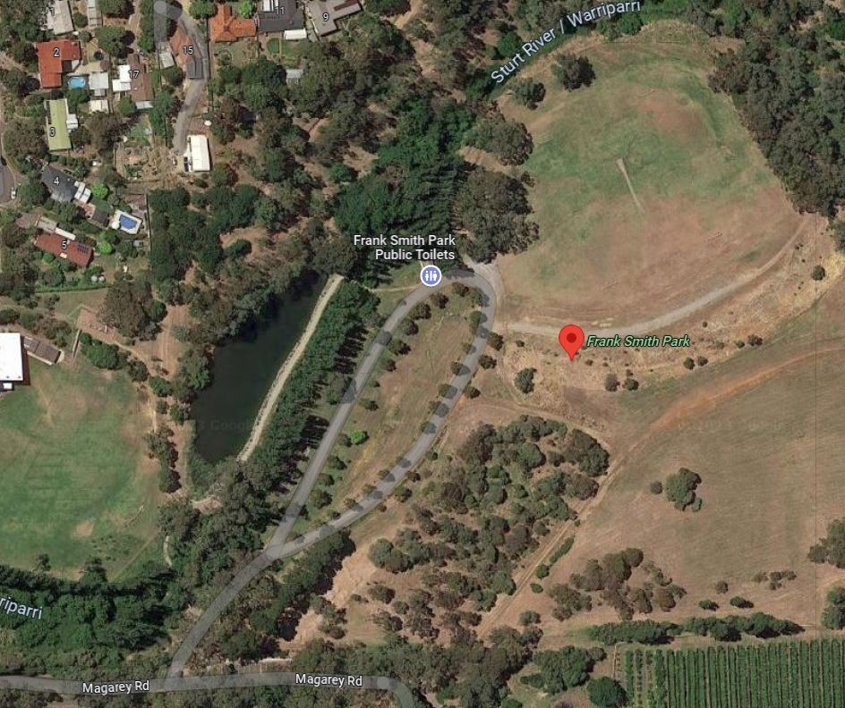
2a

2

