Home Match Details SDJSA

Home Pitch Address:

Phone: 08 8292 3888
Fax: 08 8292 3800
Website: www.emmauscc.sa.edu.au

Synthetic Pitch Corner of Lynton Avenue and Ayre Street, South Plympton 5038 Lawn Pitch Corner of Lynton Avenue and Wheaton Street, South Plympton 5038 Home Match Start Times:
Team Name / Age Group | Kick Off times | Team size and match duration | Match Pitch
Under 7 (Emmaus Eagles - SP) | 8.30am Kick-Off  (Red Division) | 7-a-side, 2 x 20min halves | Synthetic pitch
Under 7 (Emmaus Eagles - BP) | 9.30am Kick-Off (White Division) | 7-a-side, 2 x 20min halves | Synthetic pitch
Under 8 (Emmaus Eagles) | 10.30am Kick-Off  (Blue Division) | 8-a-side, 2 x 20min halves | Synthetic pitch
Under 10 (Emmaus Eagles) | 9.30am Kick-Off  (Red Division) | 10-a-side, 2 x 25min halves | Lawn pitch
Under 12 / Senior Primary (Emmaus Eagles) | 10.30am Kick-Off  (Blue Division) | 11-a-side, 2 x 25min halves | Lawn pitch

For all away matches kick off times and locations refer to your child’s relevant Team App page or the www.sdjsa.com website for more specific details

Team Playing Strips:

All teams will wear dark blue top with yellow and light blue trim with dark blue shorts and socks

College Sport (Soccer) Coordinator:
Daryl Porter
Mobile number: 0412 956 289 Email: dporter@emmauscc.sa.edu.au
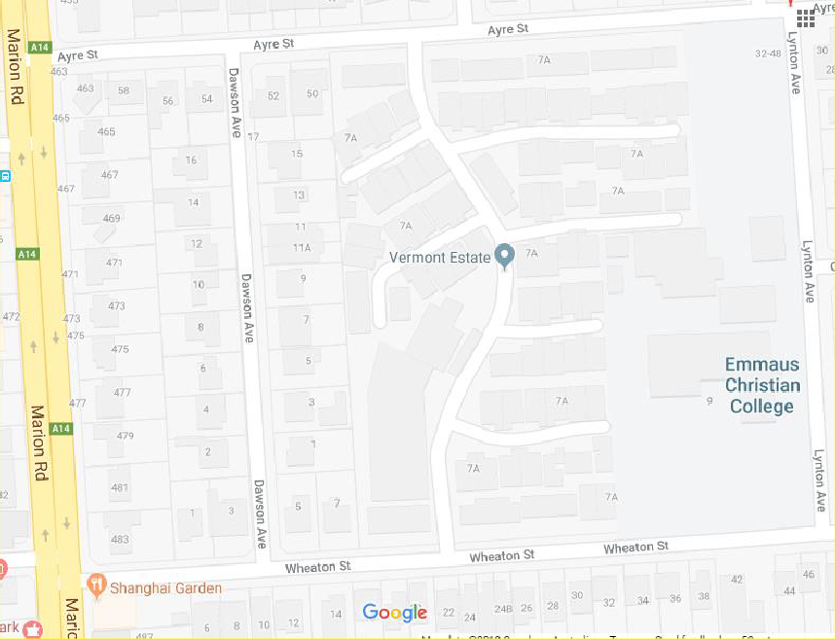General Enquiries: 08 8292 3888 Email: sport@emmauscc.sa.edu.au
Lawn Pitch
Synthetic
Pitch

