STELLA MARIS SOCCER 2023

ALL HOME GAMES IN 2023 FOR STELLA MARIS WILL BE PLAYED AT ST BERNADETTE’S PRIMARY SCHOOL
ADDRESS
54 Ragless St, St Marys SA 5042
TEAM | DIVISION | START TIME | FINISH TIME
Under 8 | WHITE | 8:05am | 8:50am
Under 9 | BLUE | 8:55am | 9:40am
Under 10 | RED | 9:45am | 10:40am
Senior Stella Maris 2 | GREEN | 10:45am | 11:40am
Senior Stella Maris 1 | RED | 11:45am | 12:40pm
STELLA MARIS SCHOOL CONTACT
James McCarthy – email: james.mccarthy@smps.catholic.edu.au
Mob: 0407 114 985

Please note:
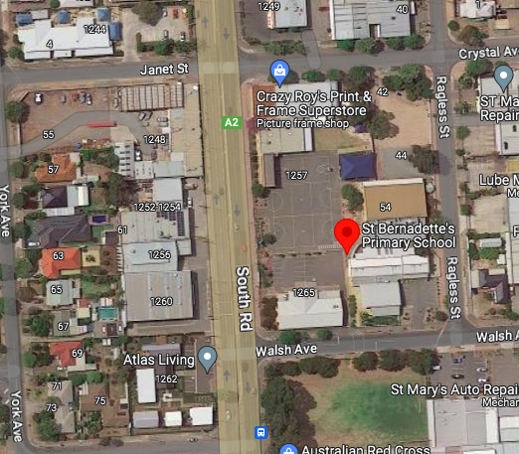
*We use 1 soccer pitch for all SDJSA home games. The goal size and pitch dimensions will remain the same for each age level (Goal size is 5x2m).

