Sunrise Christian School – MARION

**Soccer Coordinator**

Caleb Cure – 0431 019 424

**Game Location**

Sturt Marion Thunder Soccer Club pitches. Located within the Marion Sports and Community Club facilities.

Address: 262 Sturt Road Marion, SA 5043.

**Car Parking**

Two available parking locations:

1. Enter via Sturt Road (Club Marion carpark)
2. Enter via Norfolk Road (South Adelaide Basketball Club carpark)

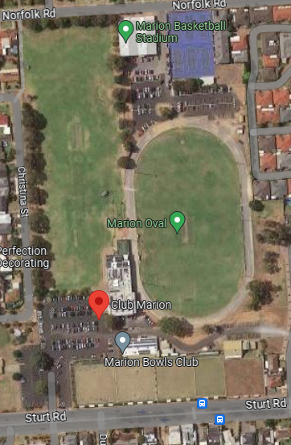

**4**

Carpark 2

**3**

**2**



**1**

Carpark 1

**Schedule for Games**

|  |  |  |  |  |
| --- | --- | --- | --- | --- |
|  | **Pitch 1** | **Pitch 2** | **Pitch 3** | **Pitch 4** |
| **8:00am** | U7 (White) | U9 (Green) | U10 (Green) |  |
| **9:00am** |  | U9 (Red) |  | Senior (White) |