UPPER STURT PRIMARY SCHOOL – SENIOR PRIMARY

LOCATION: 4 SEYMOUR STREET, EDEN HILLS
CONTACT: Ashley Wass, 0404 478 625, wassy76@hotmail.com

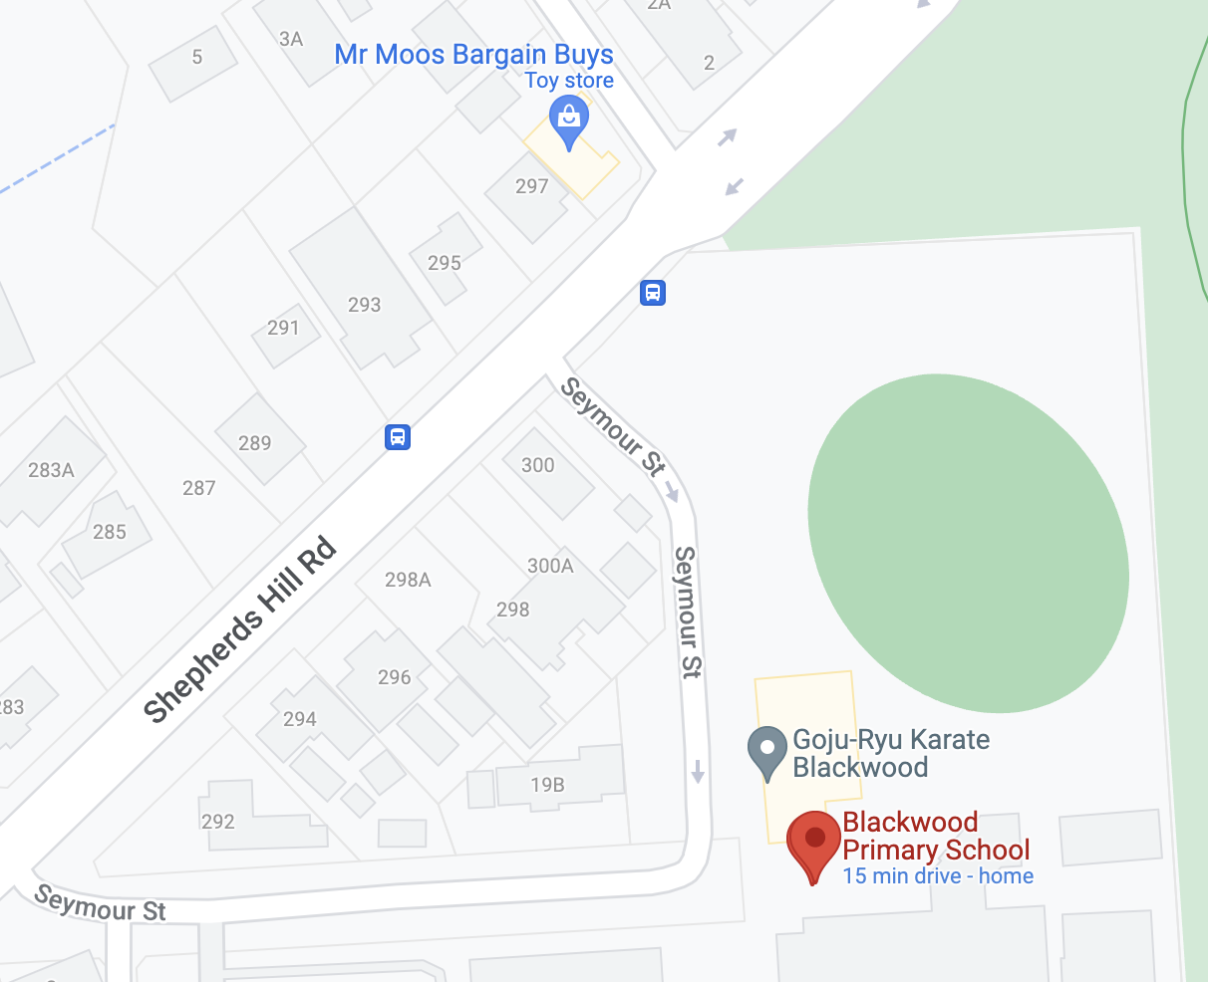
SOCCER GAMES PLAYED ON FRONT OVAL

PLAYING TIMES:

TEAM | TIME
Seniors | 8:00am

