**Aberfoyle Park Primary School CAMPUS**

2 Campus Drive Aberfoyle Park

Brett Middleton – 0431046875

Street parking at the top of campus drive. **Do not park in ESTIA retirement village car park.**

* **Seniors Maroon**- Top Oval - Pitch 1 - 8:30am Kick off
* **Seniors Blue** – Top Oval – Pitch 2 8:30am Kick off
* **Under 10’**s- Top Oval - Pitch 1 - 9:30am Kick off
* **Under 8’s**- Middle Oval - Pitch 3 - 9:30am Kick off

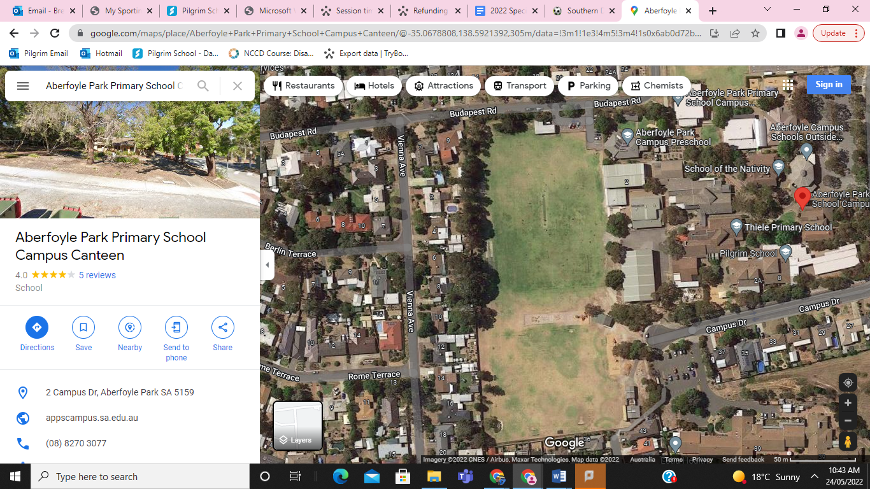

Pitch 3

Green sports Shed

COLA

Gym

Top Oval

Middle Oval

Pitch 2

Pitch 1