**Annesley Junior School Soccer 2025**



Seniors Soccer Coach:

Sim - 0415 960 222

Under 10’s Soccer Coach:

Rayan – 0447 482 384

Under 9’s Soccer Coach

Matt – 0403 069 336

Under 7’s Soccer Coach:

Rayan – 0447 482 384

Sports Co-ordinator: Penny

rawinkskip@annesley.sa.edu.au

**Seniors Home Ground - 9:30am Kick Off**

SAWSA Park, Greenhill Rd &, Peacock Rd, Adelaide SA

**Under 10’s Home Ground - 9:30am Kick Off**

SAWSA Park, Greenhill Rd &, Peacock Rd, Adelaide SA

**Under 9’s Home Ground - 8:30am Kick Off**

SAWSA Park, Greenhill Rd &, Peacock Rd, Adelaide SA

**Under 7’s Home Ground - 8:30am Kick Off**

SAWSA Park, Greenhill Rd &, Peacock Rd, Adelaide SA

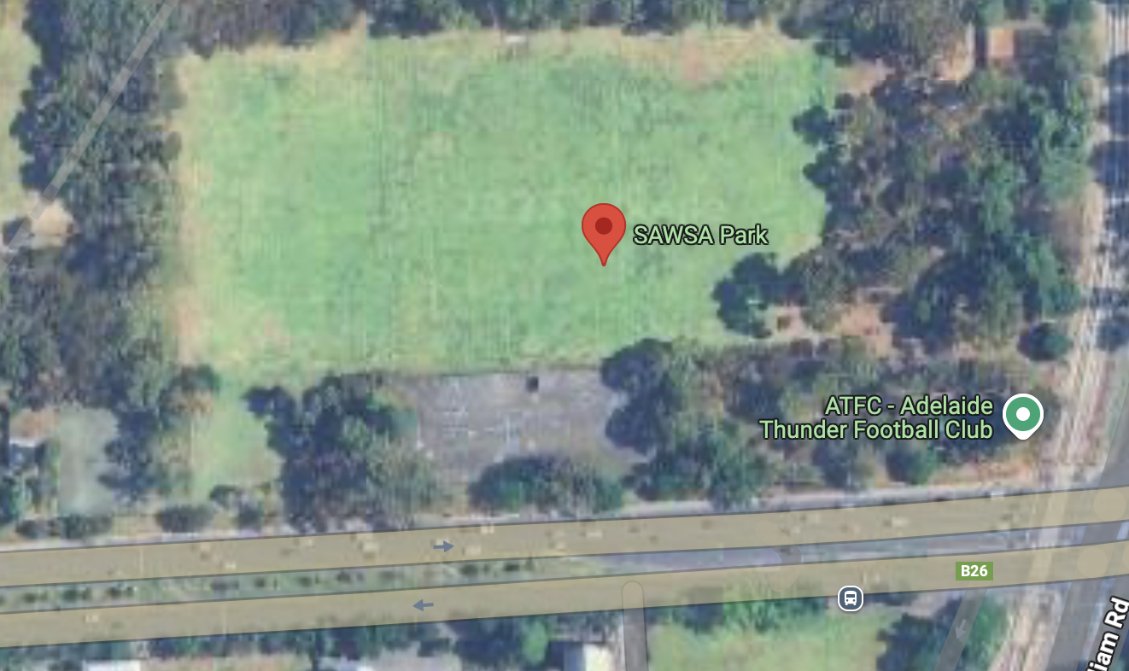

Field 2

Field 1