BRIGHTON PRIMARY SCHOOL

1 Highet Ave Brighton SA

U7 Brighton 1 = 8.30am Pitch D

U7 Brighton 2 = 9.30am Pitch D

U8 Brighton 1 = 8.30am Pitch C

U8 Brighton 2 = 9.30am Pitch C

U9 Brighton = 9.30am Pitch B

U10 Brighton 1 = 10.30am Pitch B

U10 Brighton 2 = 8.30am Pitch B

SENIOR Brighton 1 = 8.30am Pitch A

SENIOR Brighton 2 = 9.45am Pitch A

Karina Carlisle 0438 526 489

Gavin Black 0466 925 642

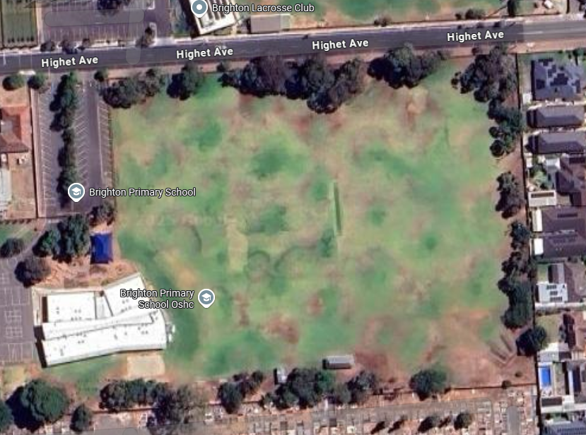

**PITCH A**

**PITCH B**

**PITCH D C**

**PITCH C**