
Seymour Street, Eden Hills
Soccer 2026 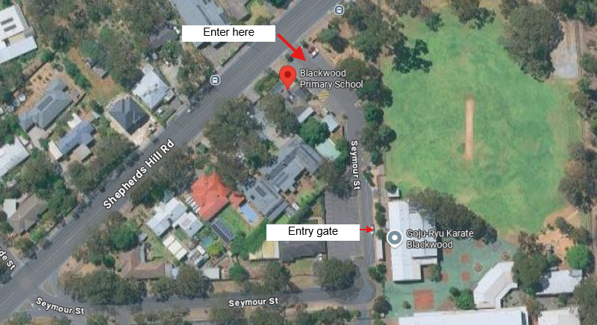
Home Game Times
TEAM | START TIME
Under 8 | 8.30am
Under 9 | 8.30am
Under 10 | 9.30am
Senior 1 - Blue | 10.30am
Senior 2 - Purple | 11.30am

Soccer Coordinator
Mardi Biggs 0419 807 019

