**Aberfoyle Park Primary School CAMPUS**

2 Campus Drive Aberfoyle Park

Street parking at the top of campus drive. Do not park in ESTIA retirement village car park.

**Under 9’s**- Middle Oval - Pitch 1 - 8:30am Kick off

**Under 10’**s- Top Oval - Pitch 3 - 9:30am Kick off

**Seniors**- Top Oval - Pitch 4 - 8:30am Kick off

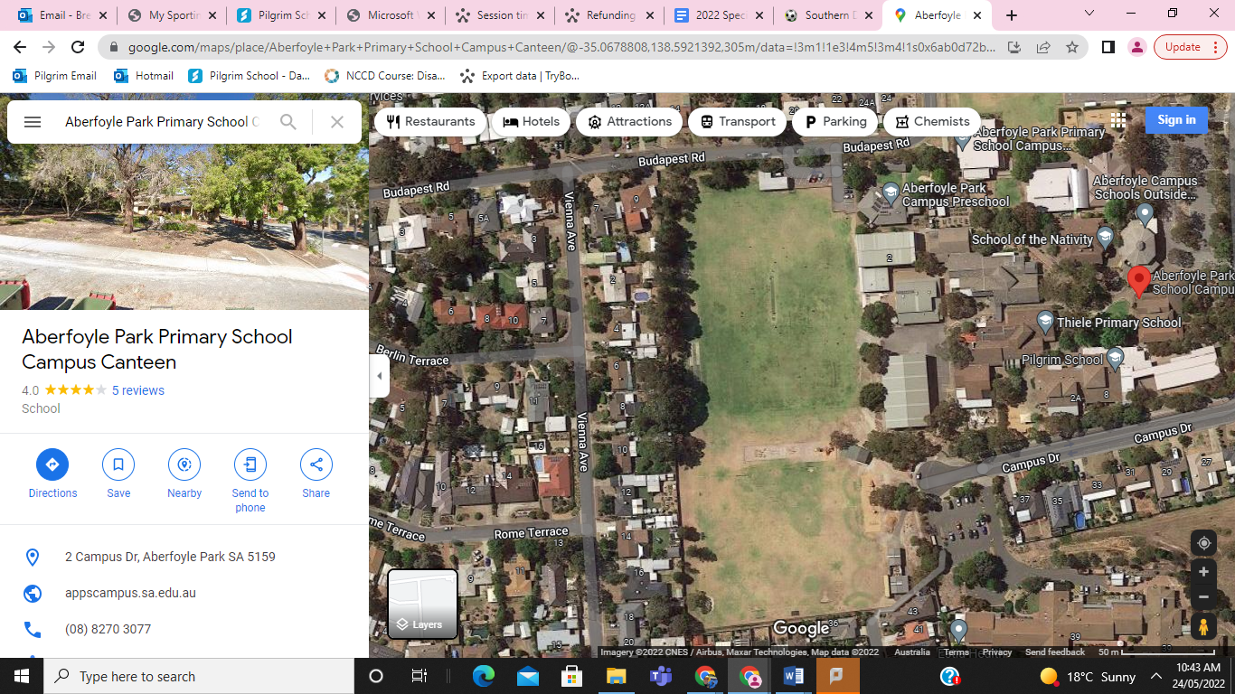

Green sports Shed

COLA

Gym

Top Oval

Middle Oval

Pitch 4

Pitch 3

Pitch 2

Pitch 1