**School Name**: Concordia College- St John’s Campus

**Address**: Enter via 24 Winchester Street, Highgate SA 5063

**Sports Coordinator**: Mick Phillips mobile: 0408 842 485 Email: [mphillips@concordia.sa.edu.au](mailto:mphillips@concordia.sa.edu.au)

**Team Contacts**

|  |  |  |  |
| --- | --- | --- | --- |
| **Team** | **Home Game Time** | **Contact Name** | **Contact Number** |
| **U8’s** | **8:00am** | **Graham Buxton** | **0423079472** |
| **U9’s** | **8:45am** | **Tim Papanestoras** | **0413246713** |
| **U10’s** | **9:30am** | **Kristy Macfarlane** | **0402557527** |
| **Senior Primary 2 Orange (Yr 5)** | **10:30am** | **Natasha Sellan** | **0413628739** |
| **Senior Primary 1 Red (Yr 5)_** | **11:30am** | **Ben Stephan** | **0414646236** |

|  |  |  |  |  |  |
| --- | --- | --- | --- | --- | --- |
| **DATE** | **8:00am** | **08:45am** | **9:30am** | **10:30am** | **11:30am** |
| **25-May-24** | **U8 Blue** | **U9 Green** | **U10 Red** | **Senior 2 Orange Yr 5** | **Senior 1 Red Yr 6** |
| **01-Jun-24** | Away Game | Away Game | Away Game | Away Game | Away Game |
| **8-Jun-24** | **Long Weekend** | | | | |
| **15-Jun-24** | Away Game | Away Game | Away Game | Away Game | Away Game |
| **22-Jun-24** | **U8 Blue** | **U9 Green** | **U10 Red** | **Senior 2 Orange Yr 5** | **Senior 1 Red Yr 6** |
| **29-Jul-24** | Away Game | Away Game | Away Game | Away Game | Away Game |
| **School Holidays** | | | | | |
| **27-Jul-24** | **U8 Blue** | Away Game | **U10 Red** | **Senior 2 Orange Yr 5** | **Senior 1 Red Yr 6** |
| **03-Aug-24** | Away Game | Away Game | Away Game | Away Game | Away Game |
| **10-Aug-24** | **U8 Blue** | **U9 Green** | **U10 Red** | **Senior 2 Orange Yr 5** | **Senior 1 Red Yr 6** |
| **17-Aug-24** | Away Game | Away Game | Away Game | Away Game | Away Game |
| **24-Aug-24** | Away Game | **U9 Green** | Away Game | Away Game | Away Game |
| **31-Aug-24** | **U8 Blue** | **BYE** | **U10 Red** | **Senior 2 Orange Yr 5** | **Senior 1 Red Yr 6** |
| **7-Sep-24** | **Make up games if required** | | | | |

**Home Game Fixture 2024**

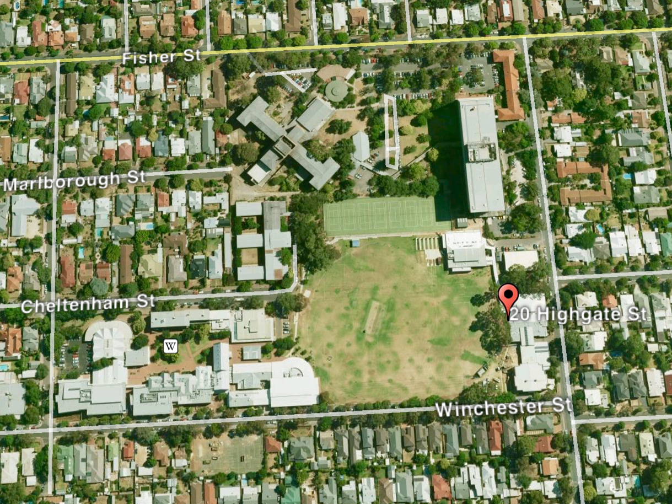

Soccer Pitch

**Oval Address 24 Winchester Street, Highgate**