**Forbes Primary School** 80 Thomas St, South Plympton

**Kick off times:**

U7s: 8:30am

U9s: 9:30am

U10s: 10:30am

**Coordinator:**

Alexander Beckington - 0491 138 434

**Team Managers:**

U7s: Alexander - 0491 138 434

U9s: Aaron - 0421 285 111 (Saturday morning only)

**Marion Rd.**

Playing field

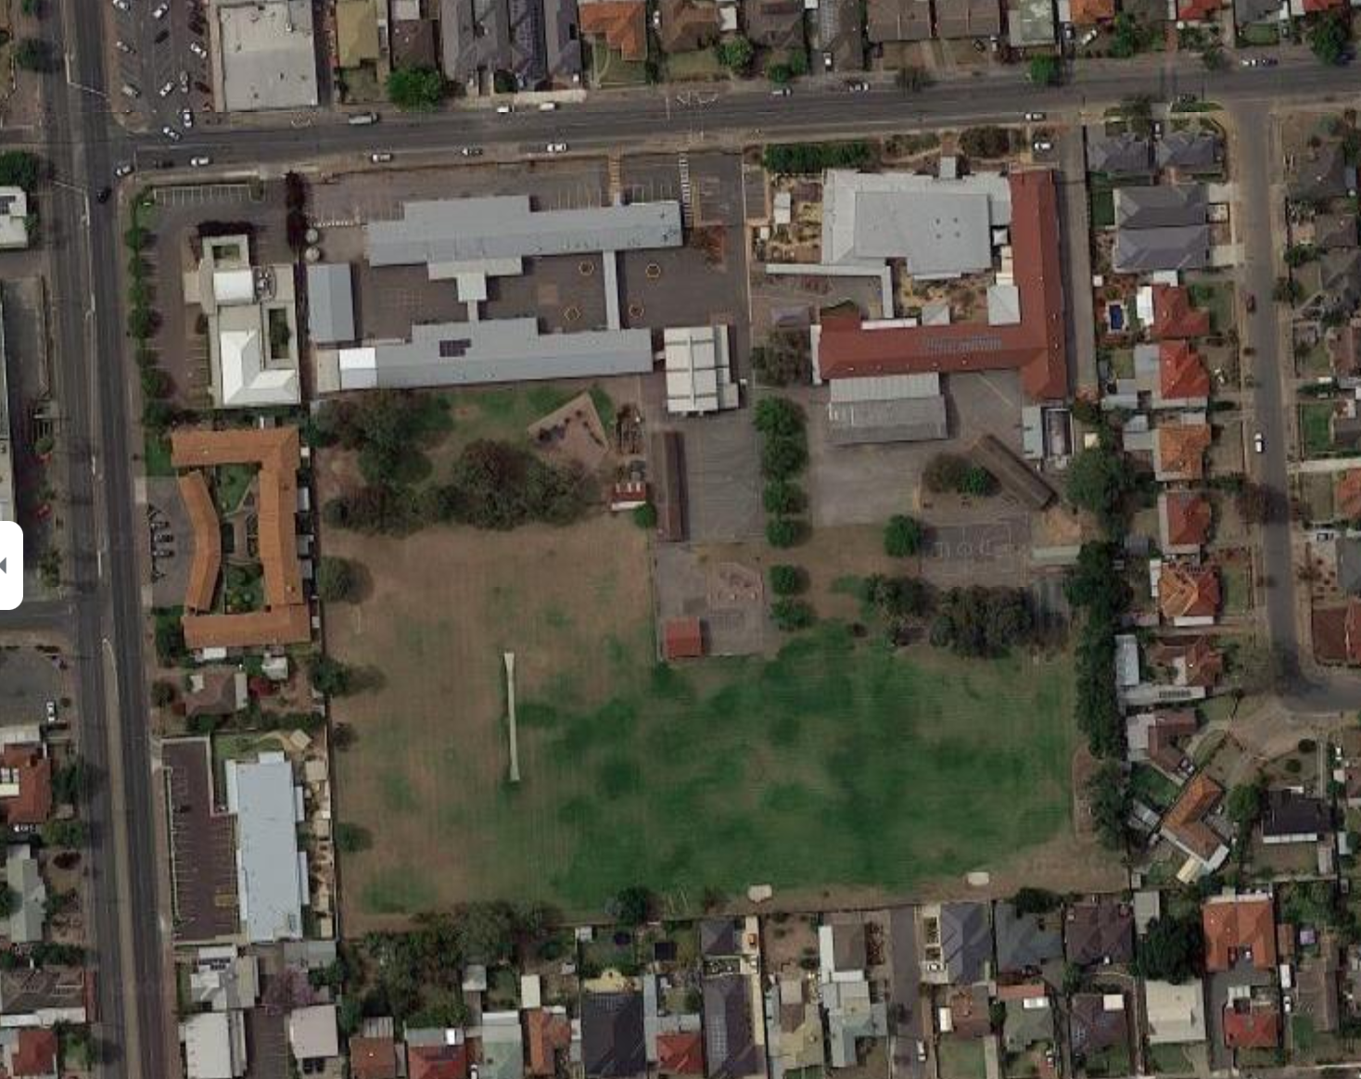U10s: Billy - 0402 182 944 (Saturday morning only)

**Thomas St.**

Entrance