**Ground: Goodwood Oval Hockey Pitch, Argyle Avenue, Goodwood**

|  |  |  |  |  |  |  |  |  |  |  |
| --- | --- | --- | --- | --- | --- | --- | --- | --- | --- | --- |
| **Kick off** | | **Small Pitch** | **North pitch** |  | | |  | | **South pitch** |  |
| **8.00am** | | U7 (Jarrad) | U8s GREEN (Matt) |  | | U9s BLUE | | | |  |
| **9.00am** | |  | U8s WHITE (James & Dave) |  | | U9s RED | | | |  |
| **10.00am** | |  | U10s GREEN (Ben) |  | | U10s WHITE (Morgan) | | | |  |
| **11.00am** | | Full pitch | Seniors – ORANGE (Mati) | | |  | |  | | |
| **12.00pm** | | Full pitch | Seniors – WHITE (Chhabbi) | |  |  | | | | |
|  |

Stephen Mitchel Kevin Hambleton  
**GPS Sports Coordinator GPS Soccer Coordinator**0401 672 856 0451 122 339

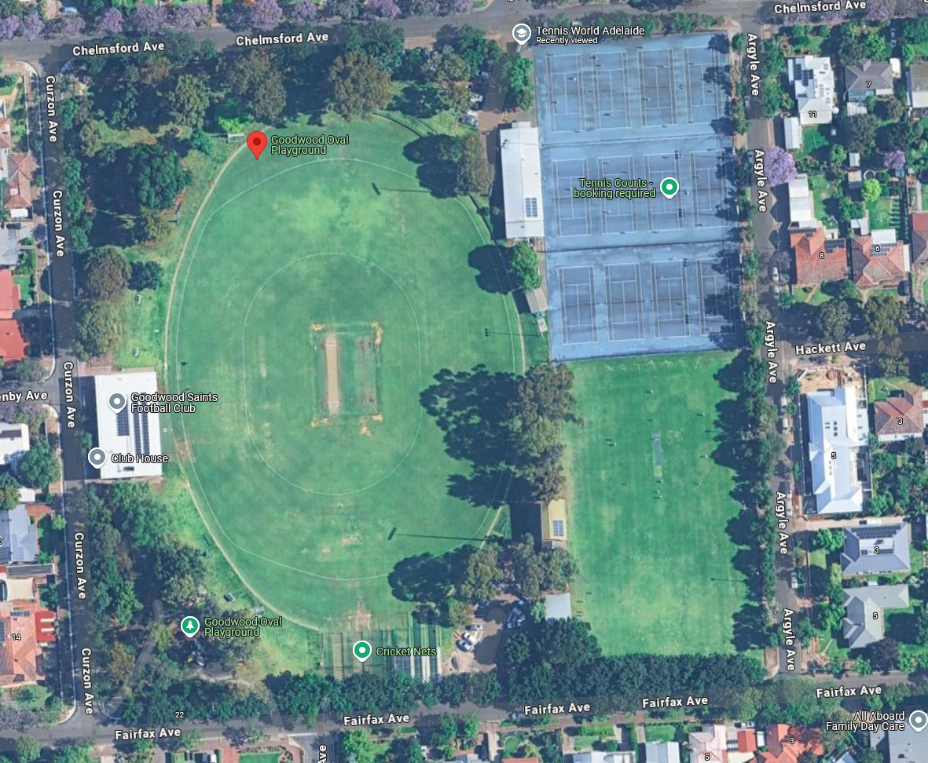

SMALL PITCH

NORTH PITCH

SOUTH PITCH