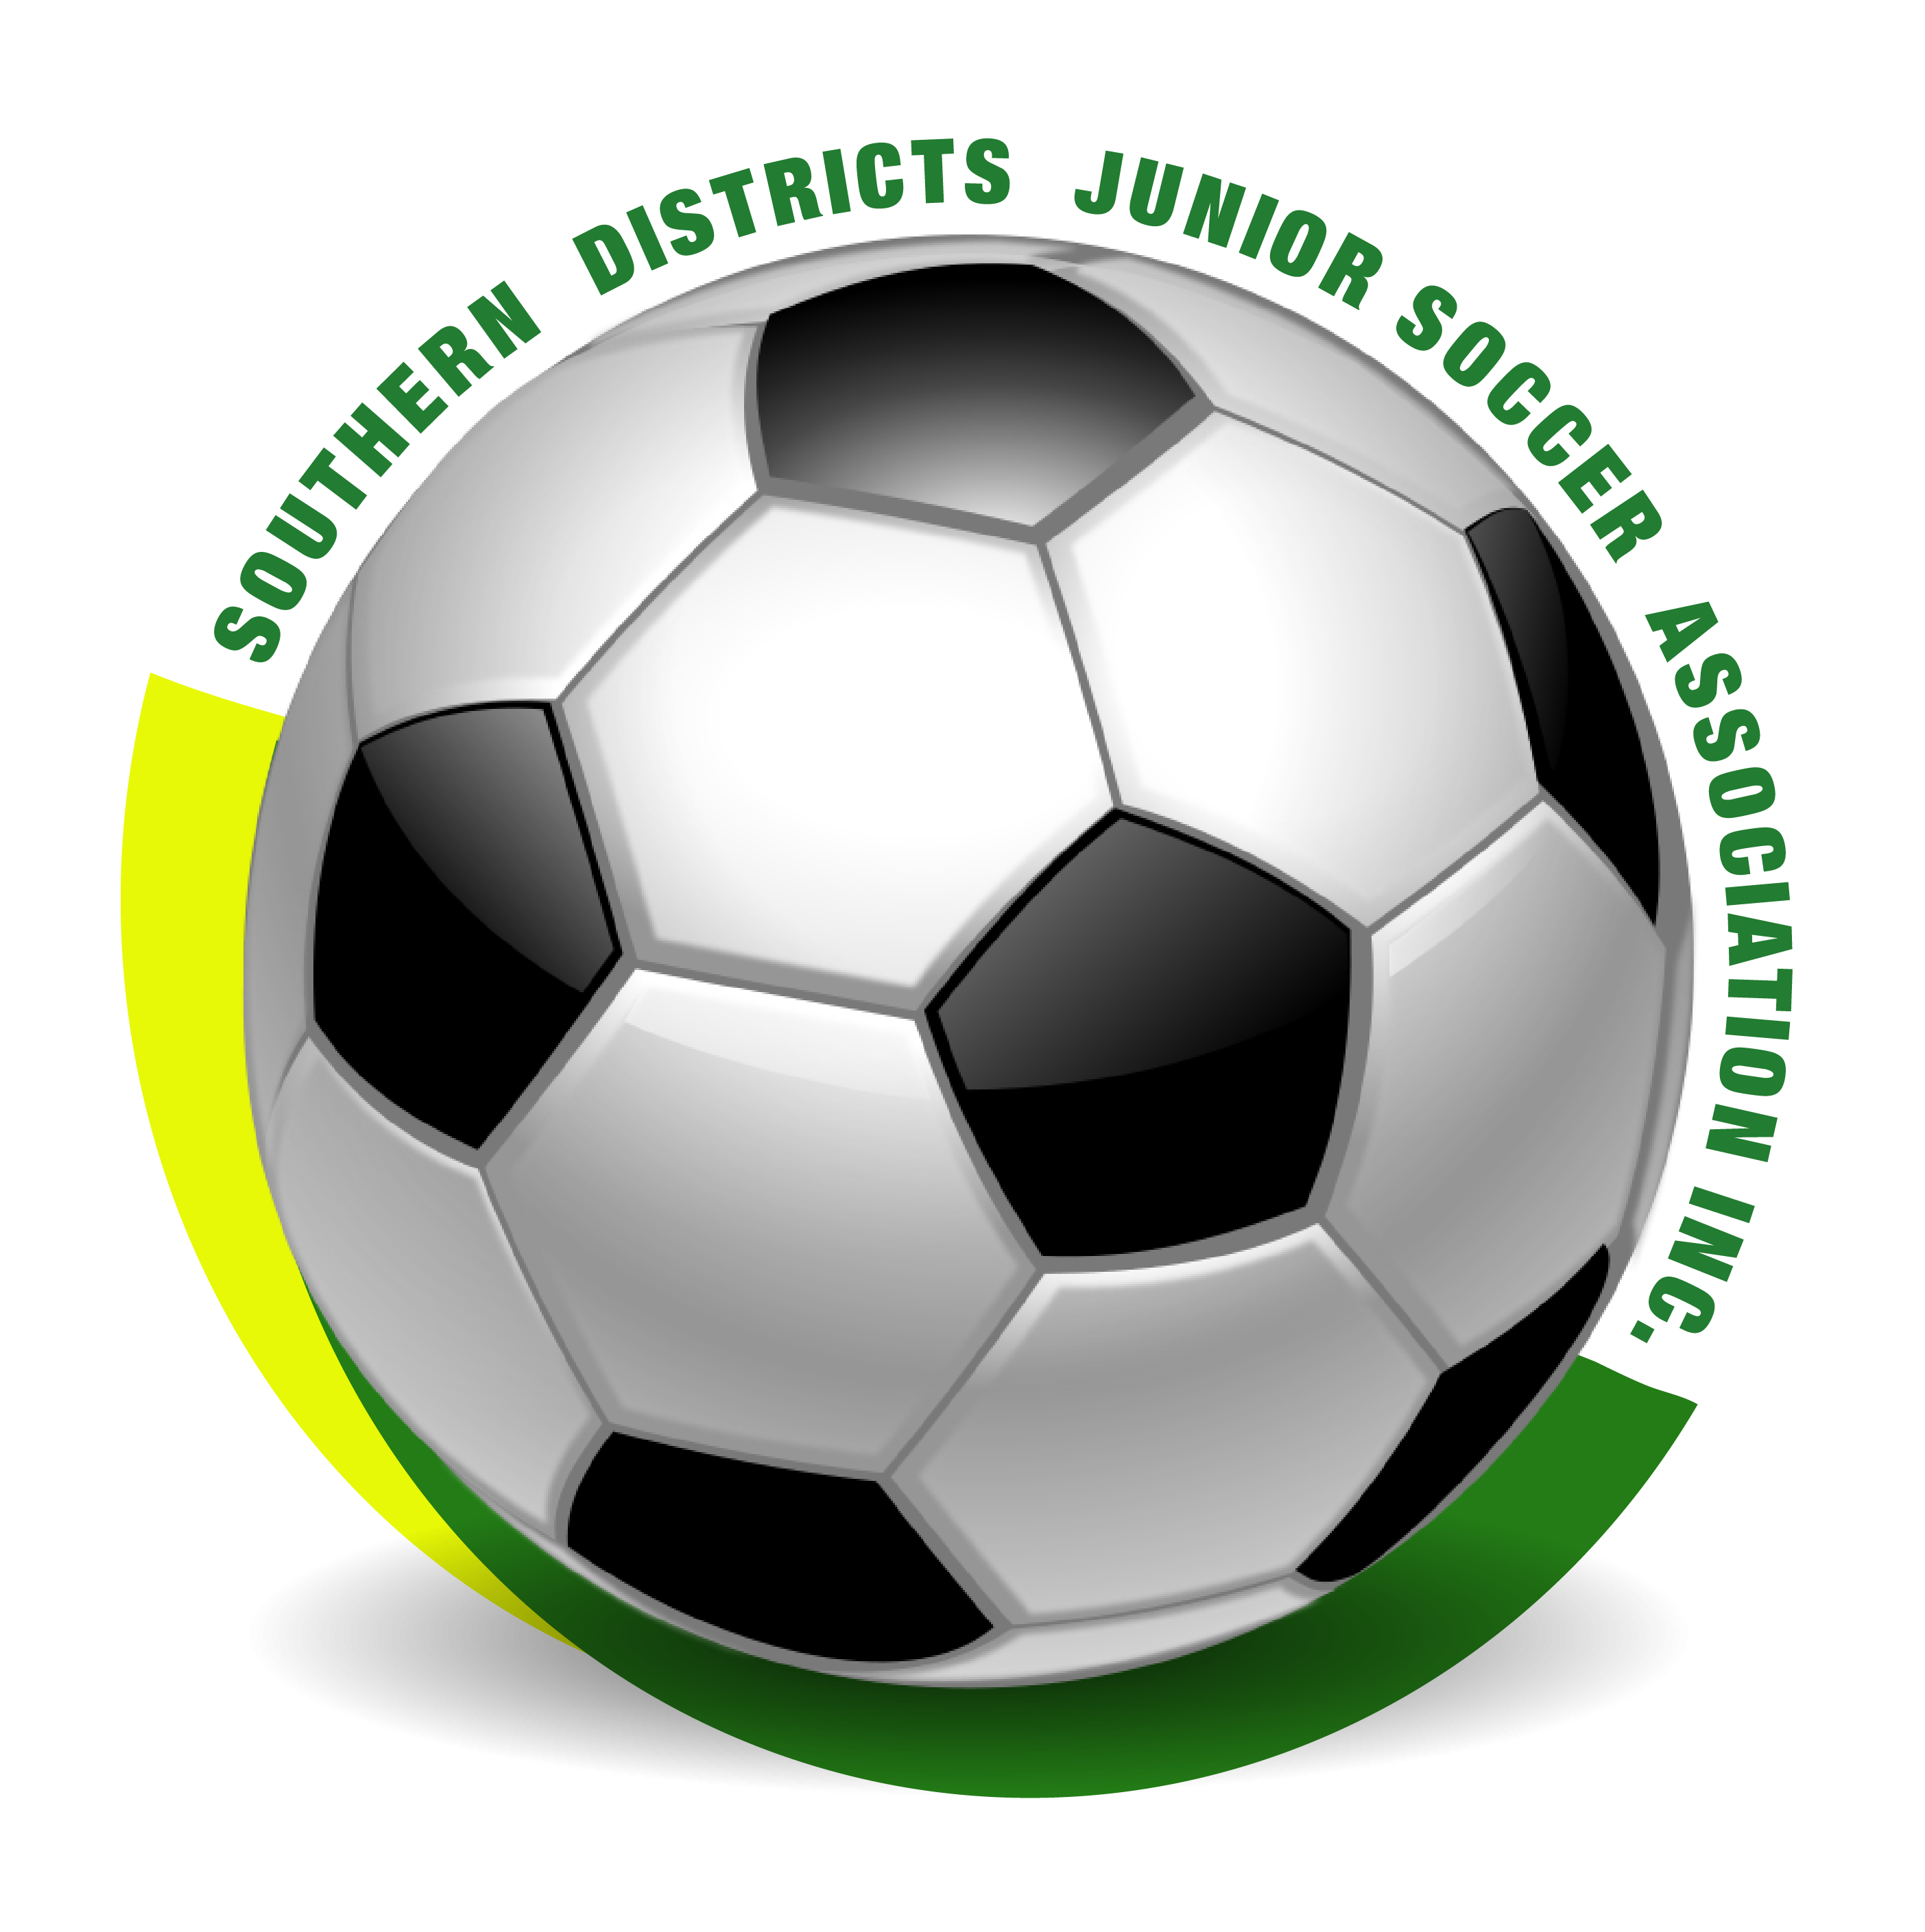
SDJSA Modified Rules – Issued April 2025

SDJSA is focused on development and ensuring that all kids have fun as they learn and play the sport. As such, all age groups are non-competitive and do not play for points.

- For under 7, 8 and 9, coaching is permitted from the playing area, except the 10-meter boxes. Coaches must not interfere with the run of play.
- A goalkeeper can be coached from behind the goal line by a nominated person in all age groups, except Senior Primary.
- All corner kicks shall be taken from the point where the 10-meter box line intersects with the goal line.
- All goal kicks and free kicks awarded within the penalty area shall be taken from the 10-meter line. All players from the opposing team must be at least 9-meters from the ball.
- Goal keepers must wear a different colour shirt to all players on the field.
- For under 10 and Senior Primary, the off-side rule will apply according to IFAB rules.
- Players shall be penalised for deliberate offenses under all circumstances.
- Penalty kicks for the nine penal offences shall be given if the referee believes the offence is intentional. All penalty kicks shall be taken as a direct free kick from the 18-yard line, and can be defended. Senior Primary penalties will apply according to IFAB rules.
- For a throw in, each player will be given a maximum of three opportunities to correctly deliver the ball.
- A size 4 ball shall be used for all age groups.
- Interchange of players may be made without stopping play at any time during the game, as long as the referee has been alerted. Unlimited interchange allowed for equal playing time.

Team size

Age group | Team size | Playing time
Under 7 | 9 a-side | 20 minutes half
Under 8 | 9 a-side | 20 minutes half
Under 9 | 9 a-side | 20 minutes half
Under 10 | 9 a-side | 25 minutes half
Senior Primary | 9 a-side | 25 minutes half

