Our Lady of Grace School – Soccer 2026
Home games are played on Mawson Oval on Kind George Avenue at Hove. Carparks are located on King George Avenue and Colton Avenue. The Oval also hosts a Catholic Schools R/1 Soccer competition from 8.30am to 10am so please allow time for parking.

Medium Pitch | Large
U8 White – 8.30am | Senior Primary Purple – 8.30am

Pitch Facilities and Locations:
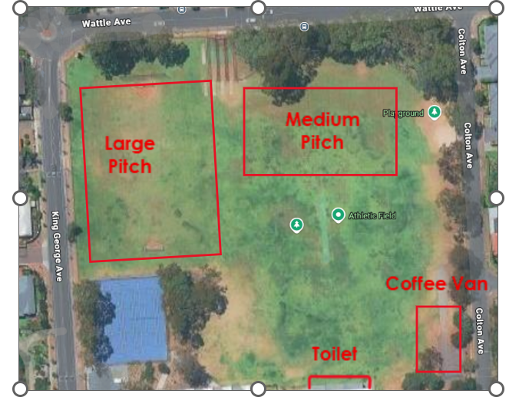
Contact People:
Under 8 White Team Manager – Bianca Robinson 0411 049 228
Senior Primary Team Manager – Rebecca Thompson 0408 824 513
School Sport Coordinator – Katie Sharkey sports@olog.catholic.edu.au

