SCOTCH COLLEGE MITCHAM CAMPUS  
PRIMARY SOCCER (YEAR 5/6 BOYS) 2025

ALL Matches will be played on Scorch College, Torrens Park Campus – Oval 2, #2 Soccer Pitch

Scotch College, Carruth Road, Torrens Park SA 5062

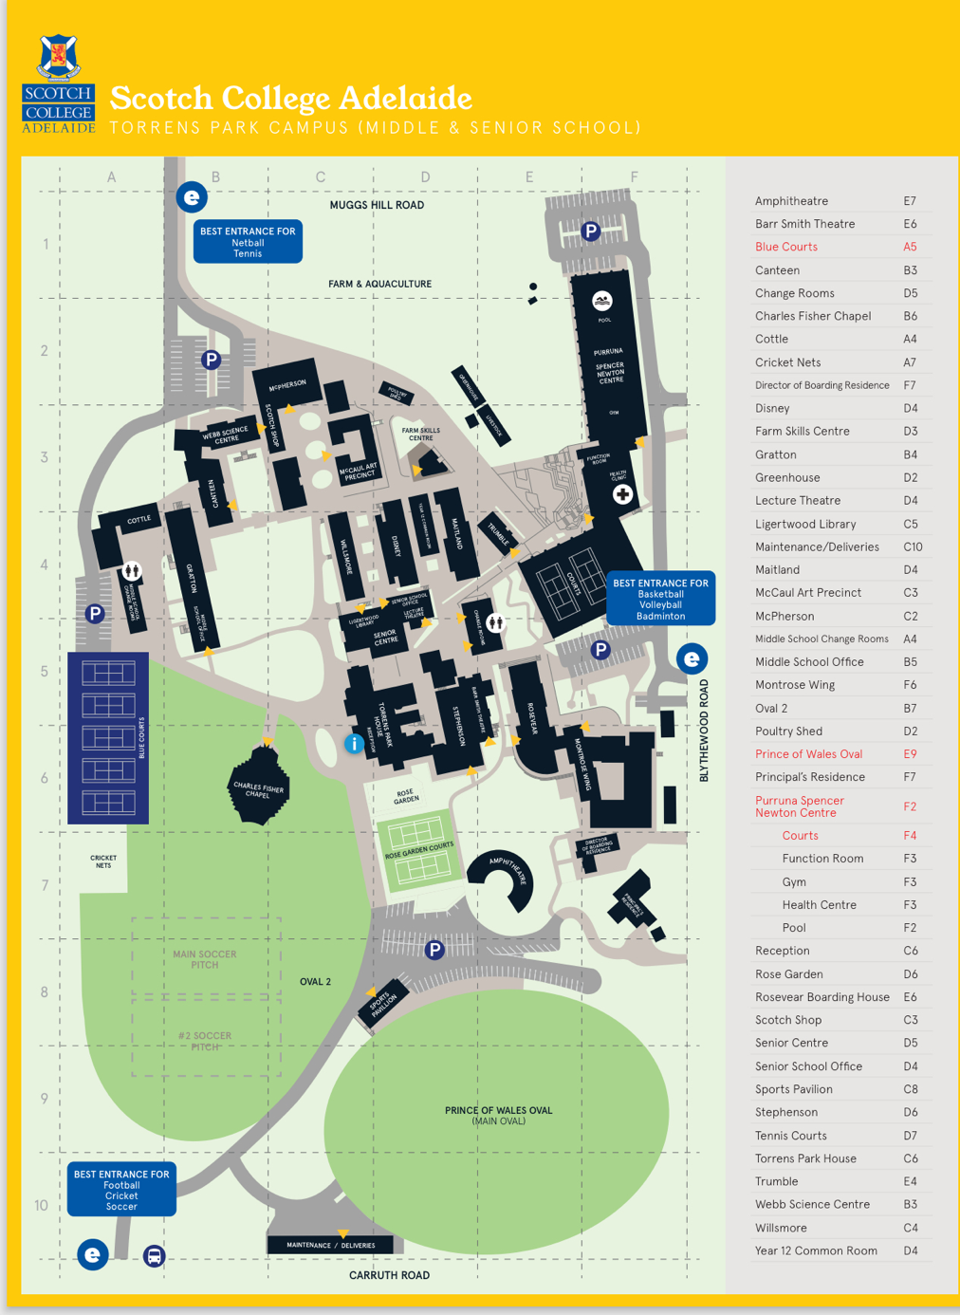

Matches will begin at 8:30am unless otherwise notified by Scotch College

Contact Person: Hannah Watkins & Paul Traino, 0427 982 620, mcsoccer@scotch.sa.edu.au