
SCOTCH COLLEGE MITCHAM CAMPUS
PRIMARY SOCCER (YEAR 5/6 BOYS) 2026

ALL Matches will be played on Scorch College, Torrens Park Campus – Oval 2, #2 Soccer Pitch
Scotch College, Carruth Road, Torrens Park SA 5062
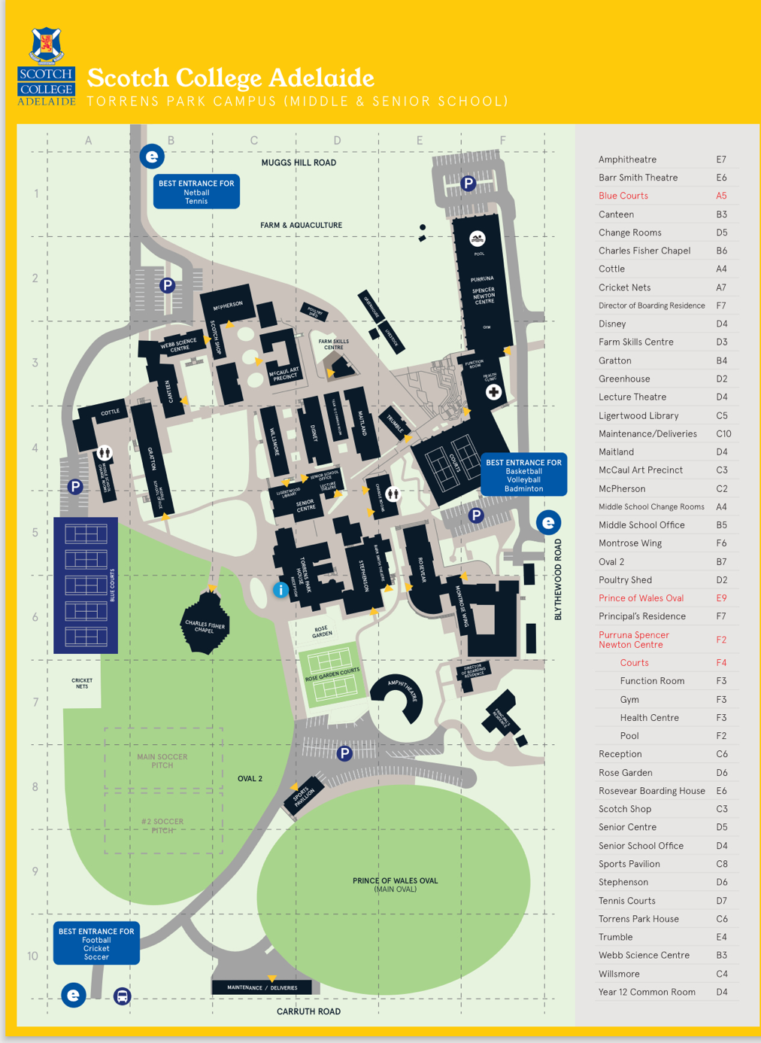

Matches will begin at 9:30am unless otherwise notified by Scotch College
Contact Person: Hannah Watkins, 0427 982 620, mcsoccer@scotch.sa.edu.au

