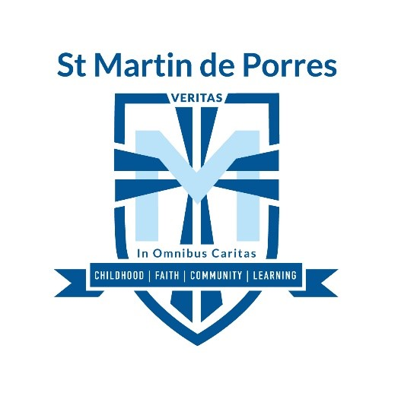

**HOME GROUND ADDRESS:** 1 Berrima Road, Sheidow Park 5158

Soccer Coordinator: Gabby Bates 8321 8300 during school hours

[gbates@smdps.catholic.edu.au](mailto:gbates@smdps.catholic.edu.au)

***HOME GAME TIMES***

Senior Primary: 9.30am

Senior Primary Coach Manager: Nicole Griggs 0407 550 929

**PLEASE NOTE:** NO DOGS ALLOWED ON PREMISES