**STELLA MARIS SOCCER SDJSA 2025**

All home games for Stella Maris this year will be played at **Darlington Primary School**

**School Address**- 9/11 White Cres, Seacombe Gardens SA 5047

|  |  |  |  |
| --- | --- | --- | --- |
| **Age Group** | **Division** | **Start** | **Finish** |
| Under 8 – STELLA 1 | RED | 8:10am | 8:55am |
| Under 8- STELLA 2 | GREEN | 9:00am | 9:45am |
| Under 9 | RED | 9:50am | 10:30am |
| Under 10 | RED | 10:40am | 11:25am |
| Senior | BLUE | 11:30am | 12:25pm |

**Please note:**

*We use 1 soccer pitch for all SDJSA home games. The goal size and pitch dimensions will remain the same for each age level (Goal size is 5x2m). There are no toilets.

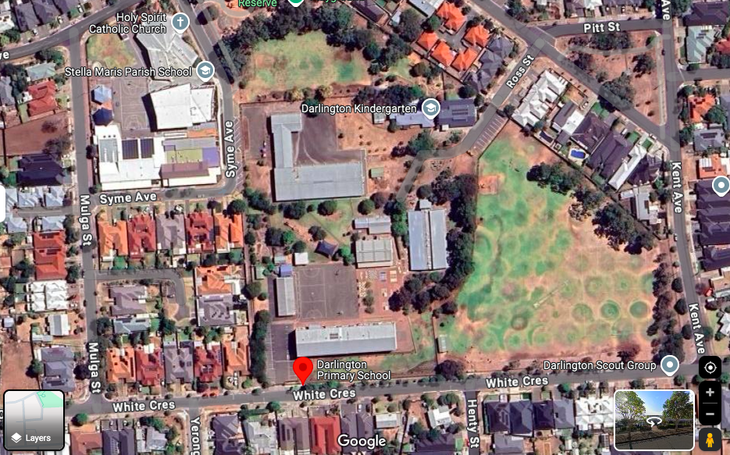



**SCHOOL CONTACT**

James McCarthy –

email: james.mccarthy@smps.catholic.edu.au

Mobile: 0407 114 985

