**SUNRISE CHRISTIAN SCHOOL**

**MARION/MORPHETT VALE**

**Grounds location:**

Sunrise Christian School – Morphett Vale. 70-74 Pimpala Road, Morphett Vale

Enter via western driveway and park in front of the grass area or down the eastern fence line. Please don’t park in front of the church or in the church carpark. Thank you. (See map below)

**Age Group and Times:**

**Age Group Division Start Time**

Under 9’s White 9:30am

Seniors Orange 9:30am

Seniors White 10:30am

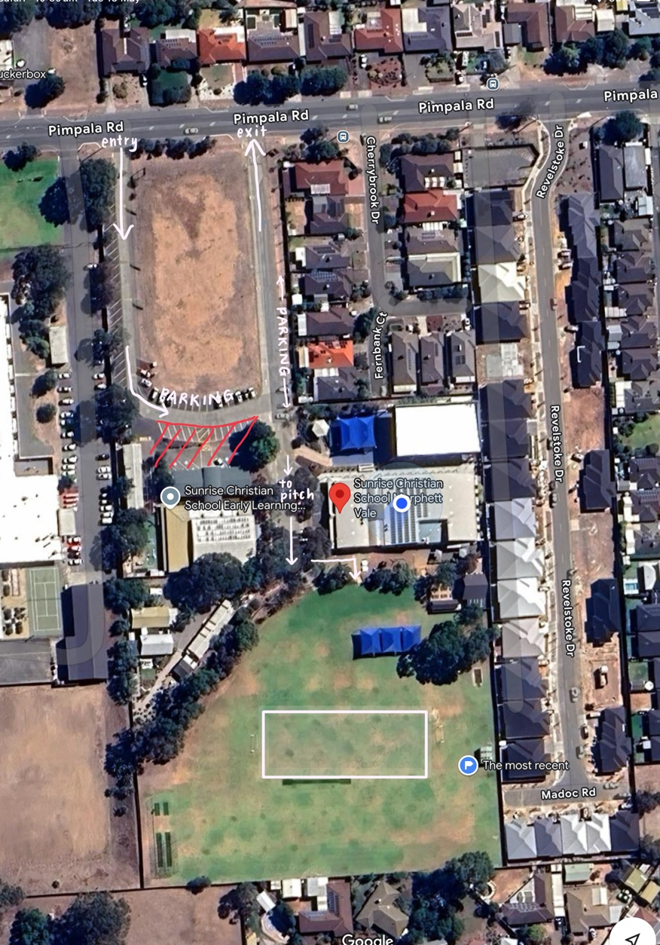**Coordinator:**

Imbi Shields – 8465 6049