


Address; 2-16 Keynes Avenue,

Warradale
Contact; 8296 2678

Game Day Coordinator
Diandra Johns – 0401 425 779

Under 7’s (Small Pitch) – Kick off 8.30am Coach- Curtis Smart
Under 8’s (Small Pitch) – Kick off 9.30am Coach- Myles Devonshire & Rebecca Gordon
Under 10’s (Large Pitch)- Kick off 9.30am Coach- Mahmood Gharooni Anaraki & Surinder Singh
Seniors (Large Pitch)- Kick off 10.30am Coach – Jack Price
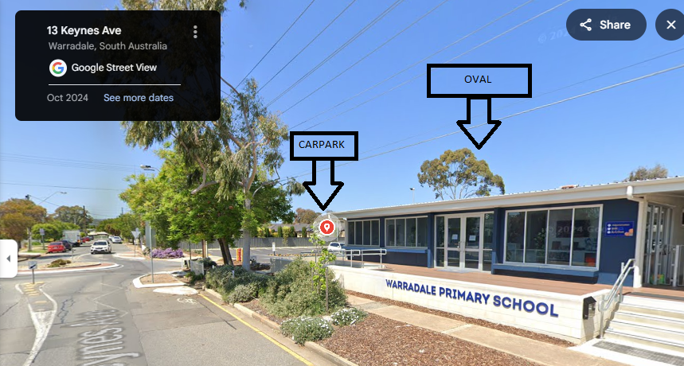

From the staff carpark you will see our Hall. Our oval is to the left/ behind the hall, closer to Morphett Road.

